**Step 1 Jenkins Setup for Gmail**

Download & share @ <https://github.com/Salihz/Jenkins-Setup-for-Gmail>

1. Make sure that the IMAP is turned on for the Gmail address you will use.

Go to this link for how to: <https://support.google.com/mail/answer/7126229?hl=en>

1. Allow Access to your same Google account you will use for Jenkins reporting.

Go to this link and click "Continue" <https://accounts.google.com/b/0/DisplayUnlockCaptcha>

1. Make sure Email Extension plugin is installed.

Go to: Manage Jenkins 🡪 Plugin Manager 🡪 Installed Tab

And check if "Email Extension" is installed. If it is not installed, click on "Available Tab" filter the results for "Email Extension" and install it.

[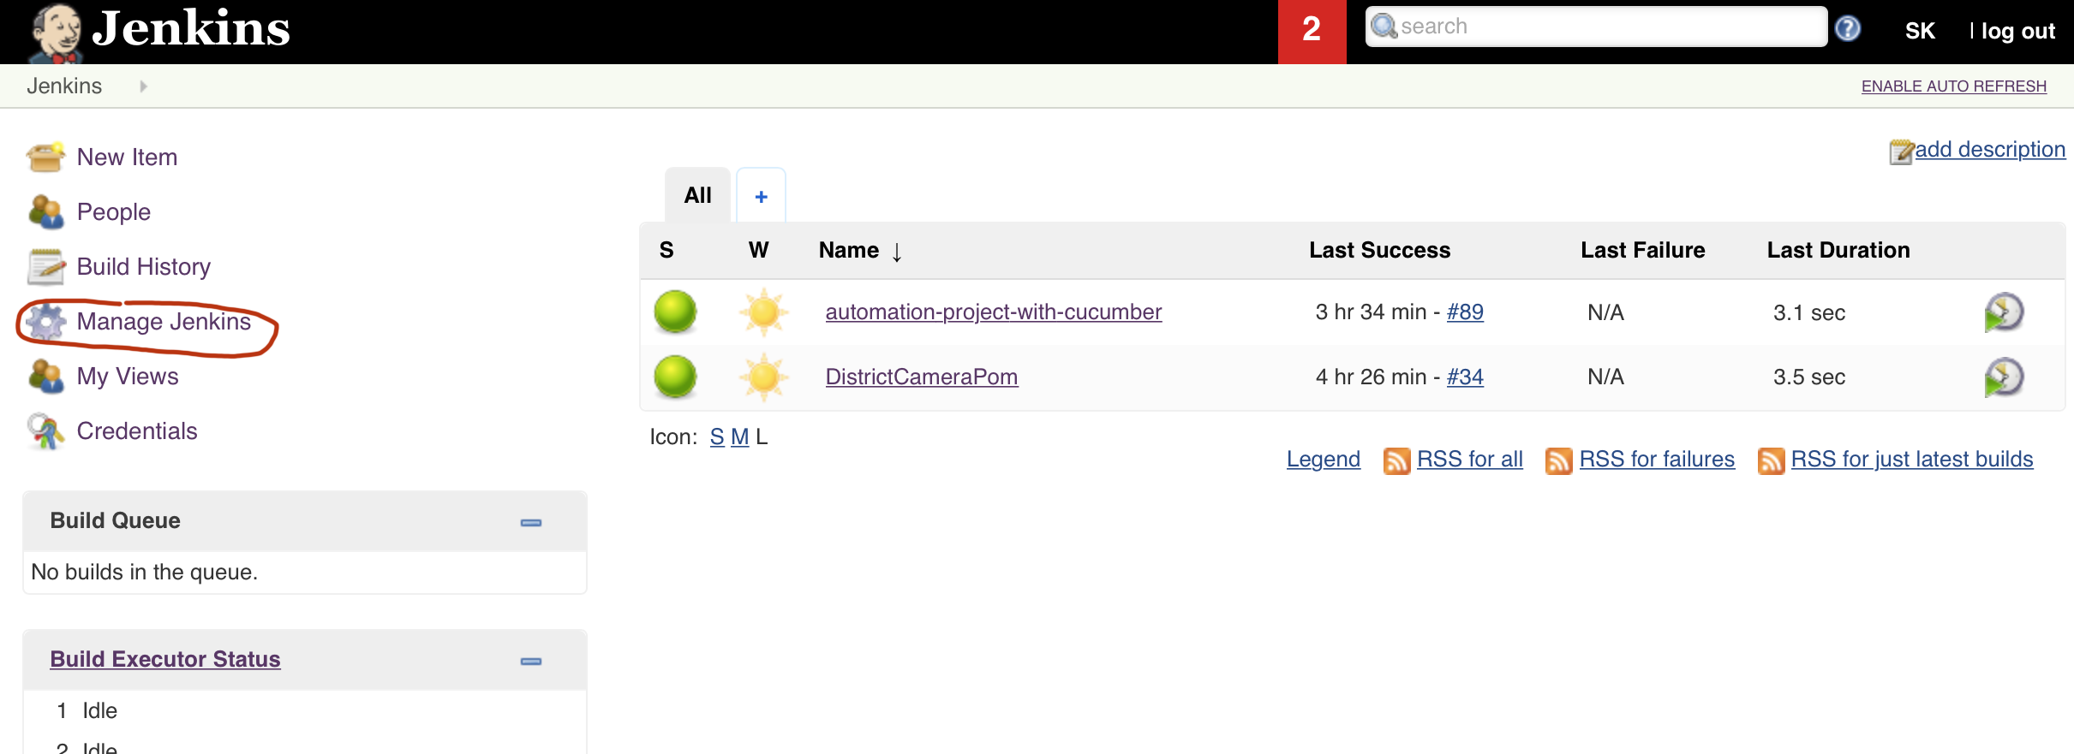](https://github.com/Salihz)

[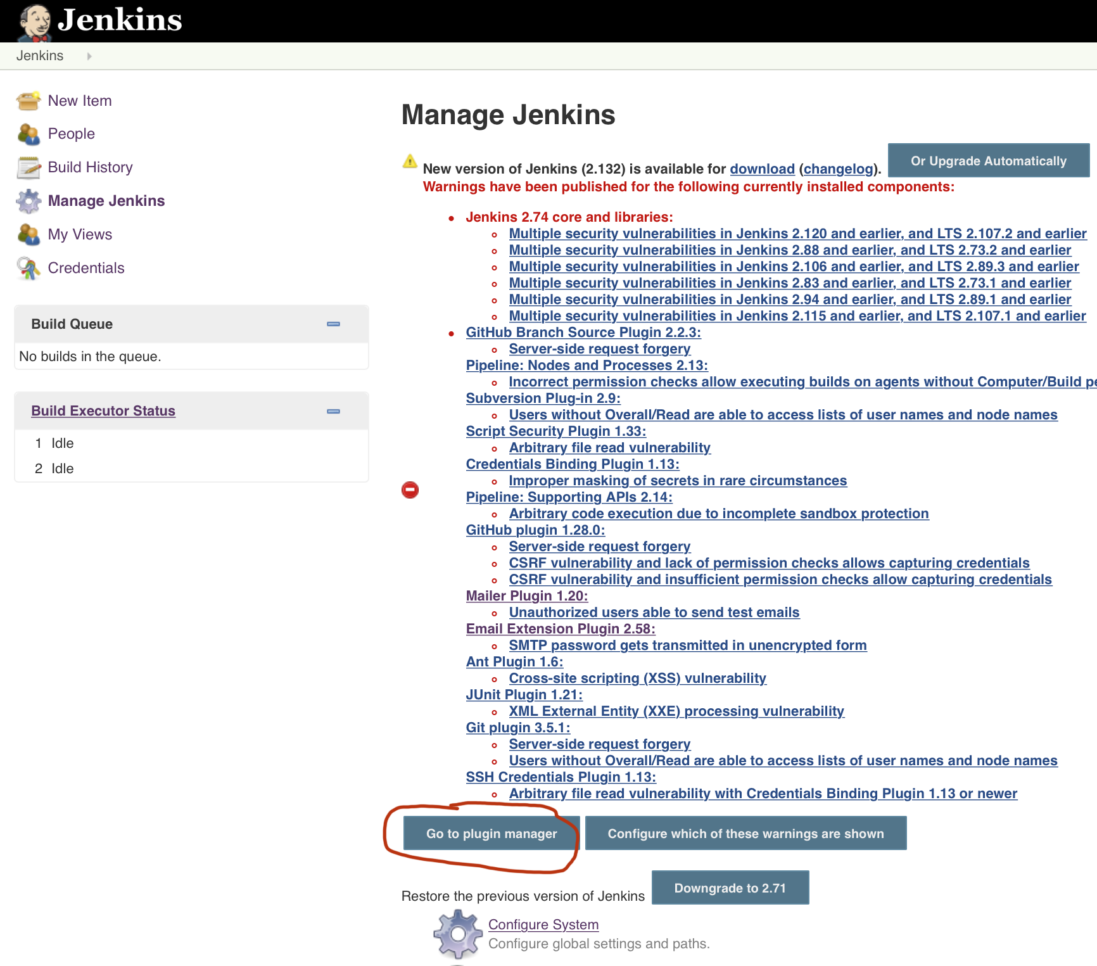](https://github.com/Salihz)

[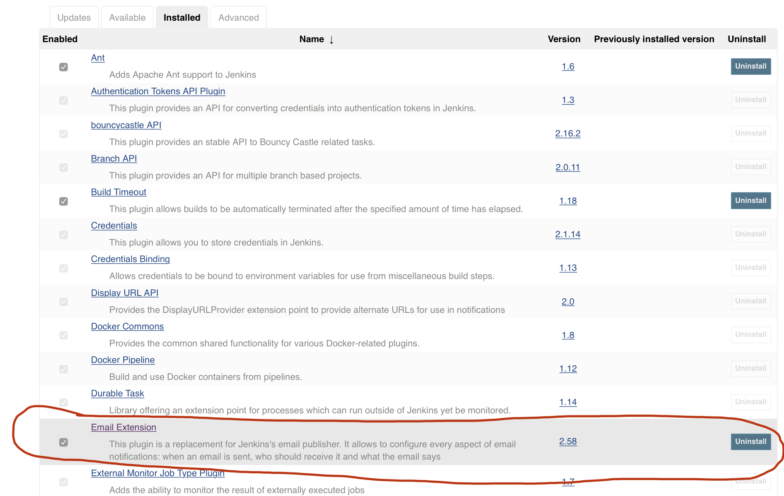](https://github.com/Salihz)

1. Now we can continue for email set up.

Go to: "Manage Jenkins" 🡪 "Configure System"

[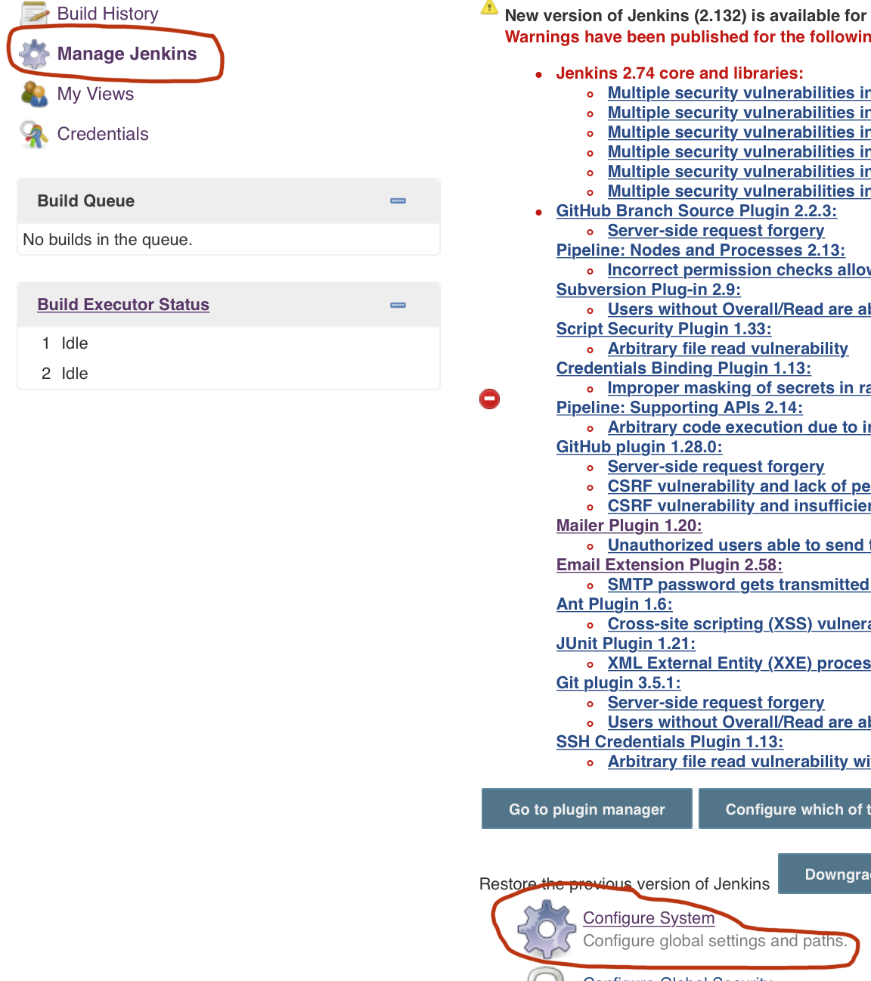](https://github.com/Salihz)

1. In the "Configuration" page, go to "Jenkins Location" and enter your Gmail address as shown below:

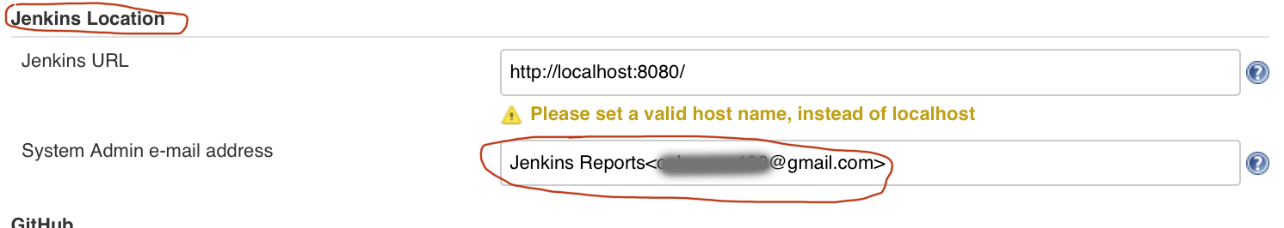

1. At the "Extend E-mail Notification" field, Click on "Advanced" button

[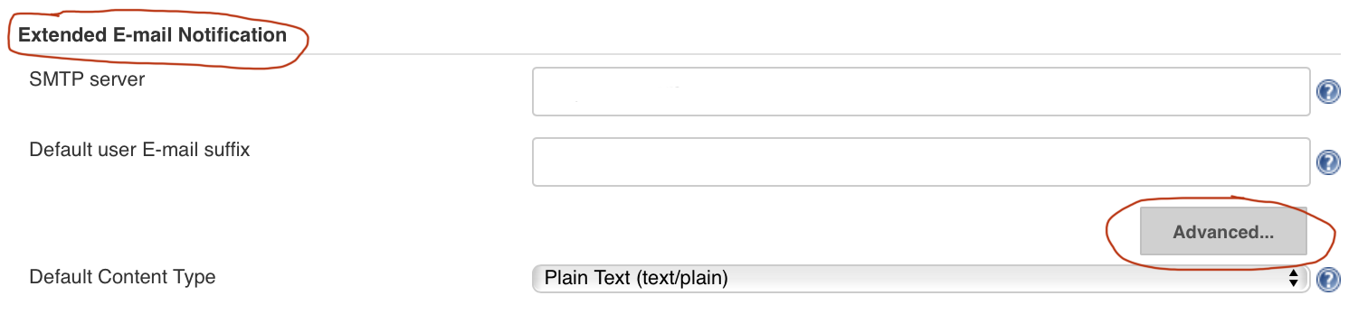](https://github.com/Salihz)

1. Complete the "Extend E-mail Notification" as shown below

Then click on the "Default Content Type", choose "Plain Text" or "HTML"

[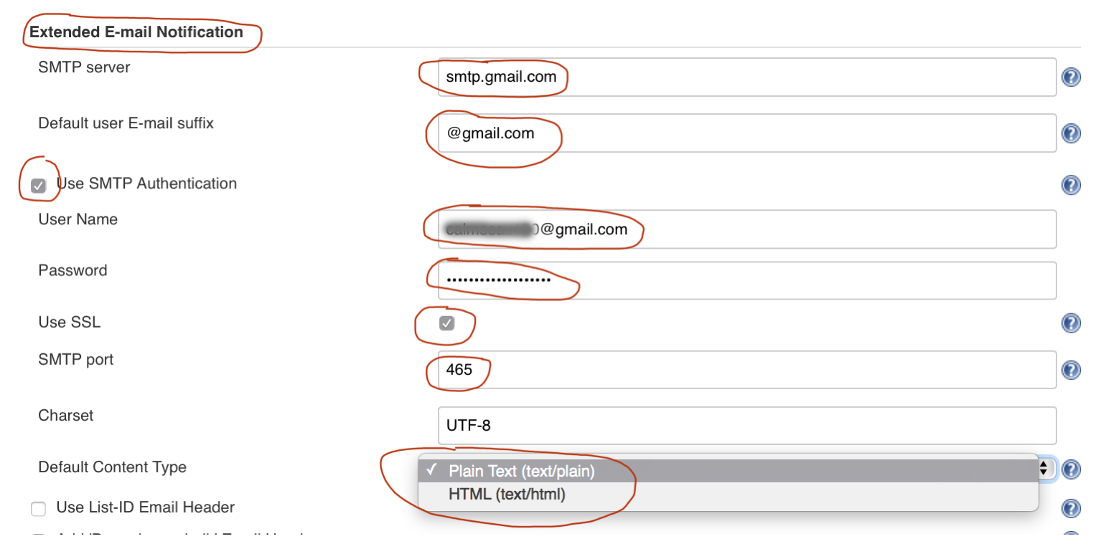](https://github.com/Salihz/Jenkins-Setup-for-Gmail)

1. Go to "Email Notification" field and click "Advanced" button

[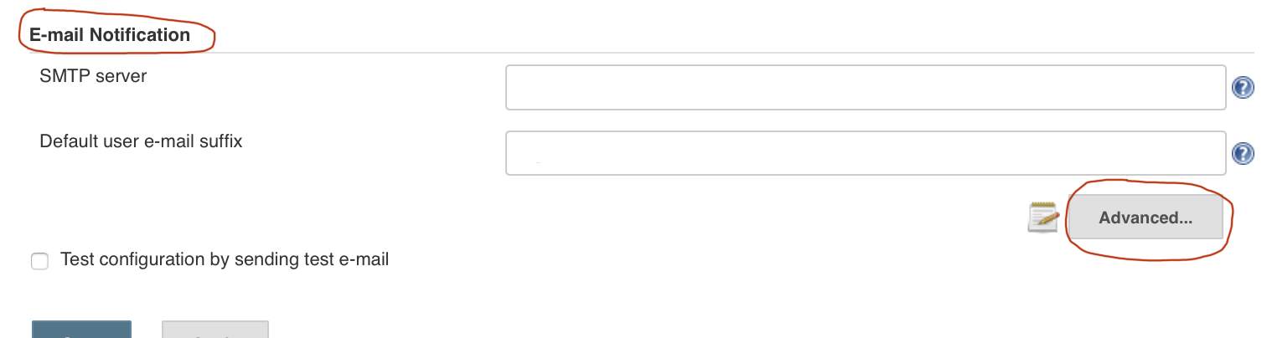](https://github.com/Salihz)

1. Complete this field as shown below, then click on "Test configuration" button

[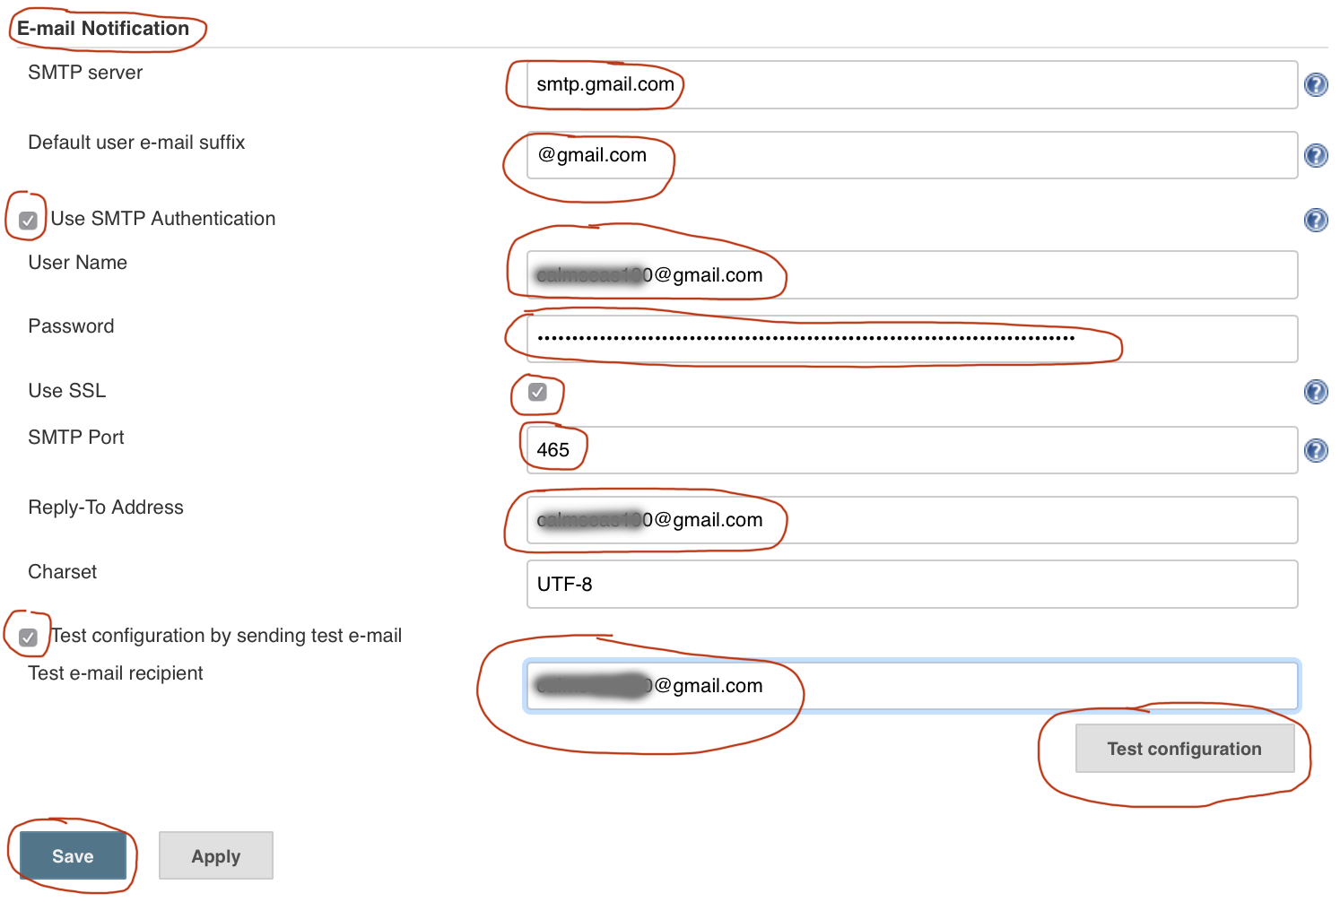](https://github.com/Salihz)

10. After clicking the "Test configuration" button you will see "Email was

successfully sent" text as seen below picture. And, an e-mail must be received

from Jenkins by the e-mail address you used for test.

[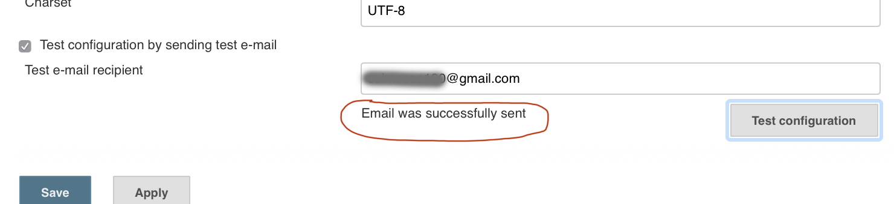](https://github.com/Salihz)

**Step 2 Jenkins Setup for Gmail**

1. Go to your builds and click the one you prefer to receive an email report from

[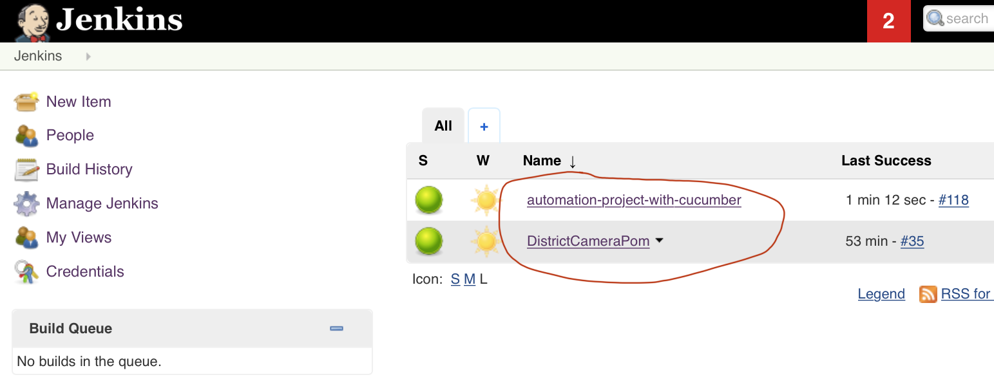](https://github.com/Salihz)

1. Click on "Configure"

[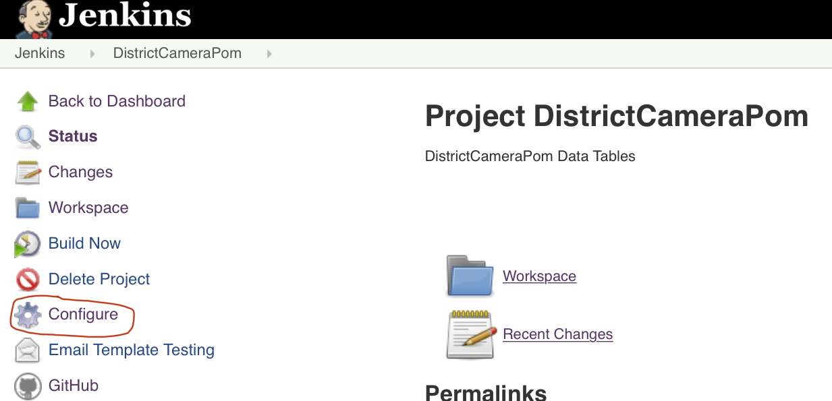](https://github.com/Salihz)

1. At "Build Triggers" field, check "Build periodically" box and enter "Schedule"

In this example Jenkins will build every other 59 minutes (H/59****)

[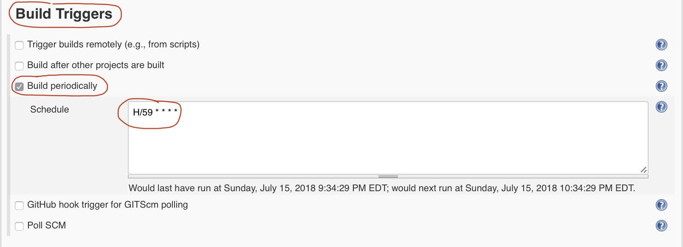](https://github.com/Salihz)

If you click on  mark next to "Schedule" field you can access the syntax and examples.

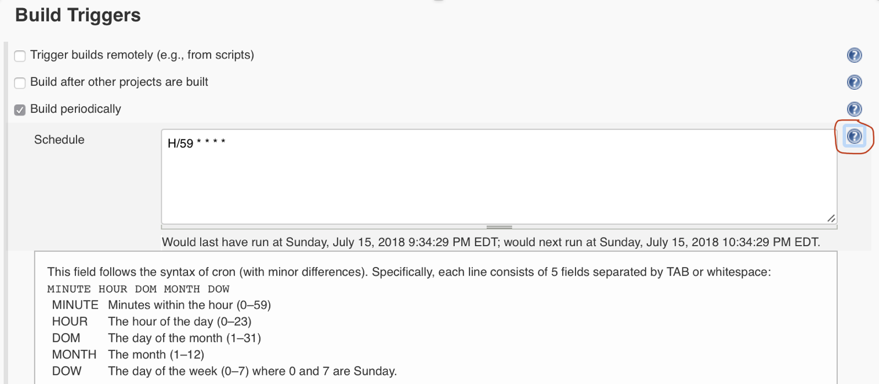

External sources for Schedule:

<https://en.wikipedia.org/wiki/Cron>

<https://crontab.guru/>

<https://www.lenar.io/jenkins-schedule-build-periodically/>

1. Go to "Post-build Actions" field and enter the "Project Recipient List" can be multiple recipient (click on question button to see how)

[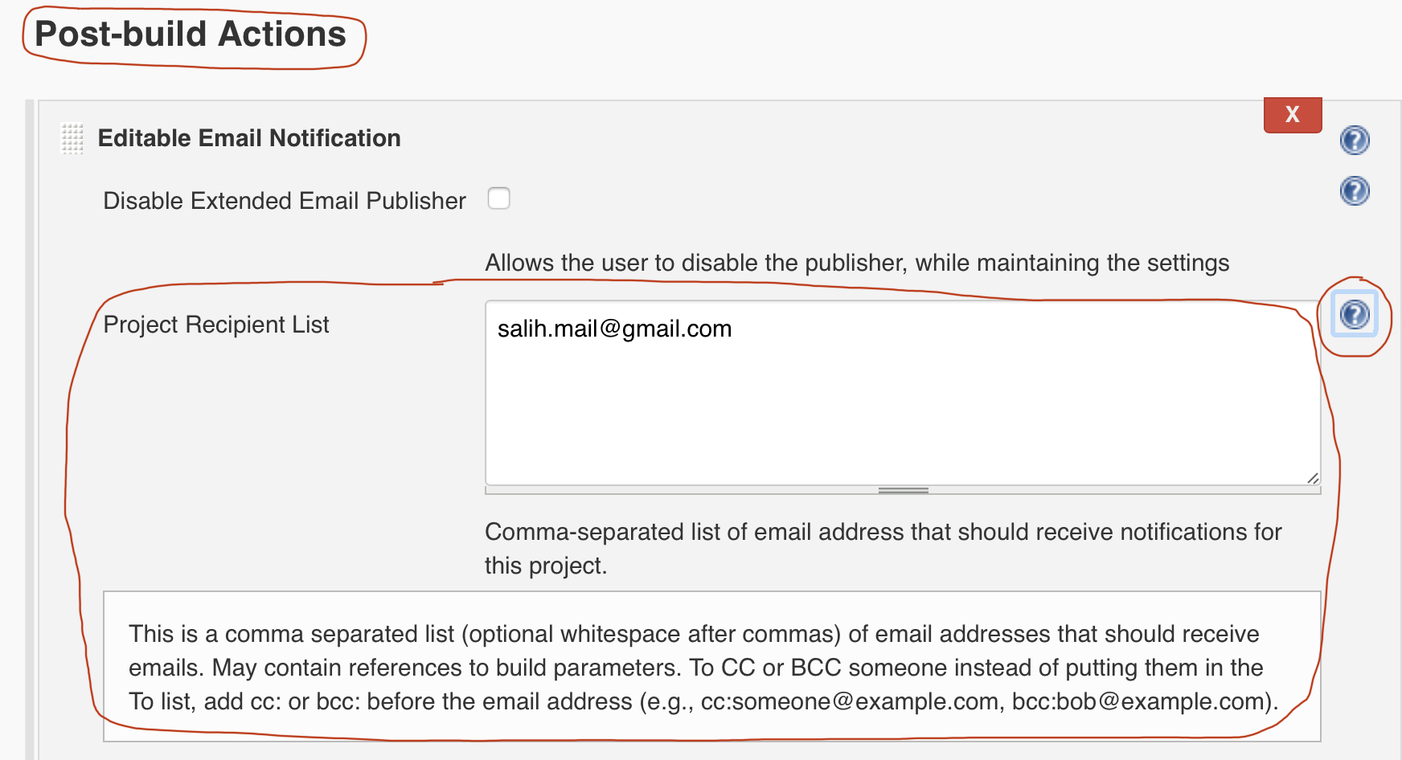](https://github.com/Salihz)

1. If you like to attach the "Build Log" to the email click on "Attach Build Log" button and choose from drop down (see next two pictures)

[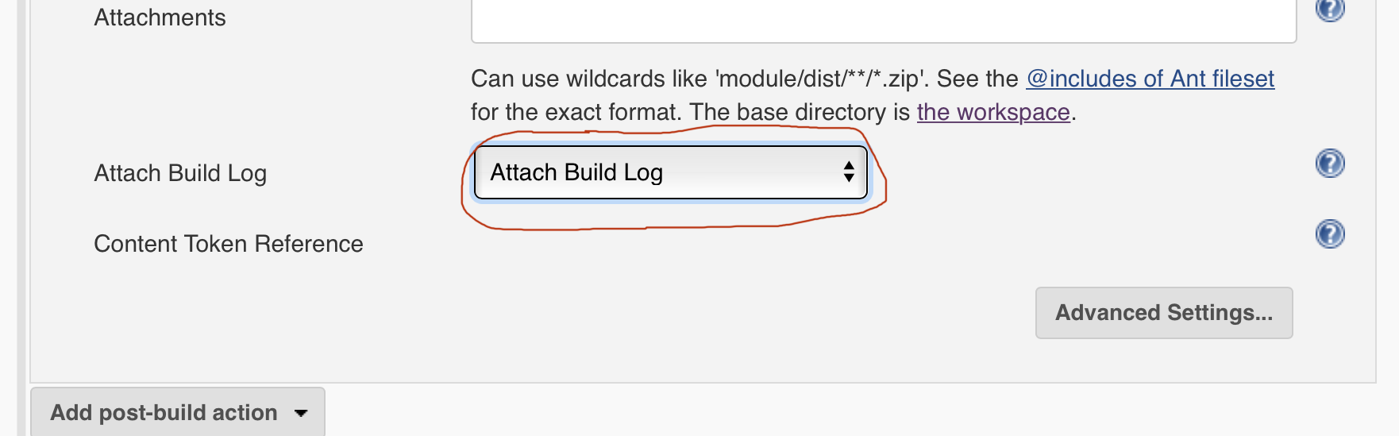](https://github.com/Salihz)

[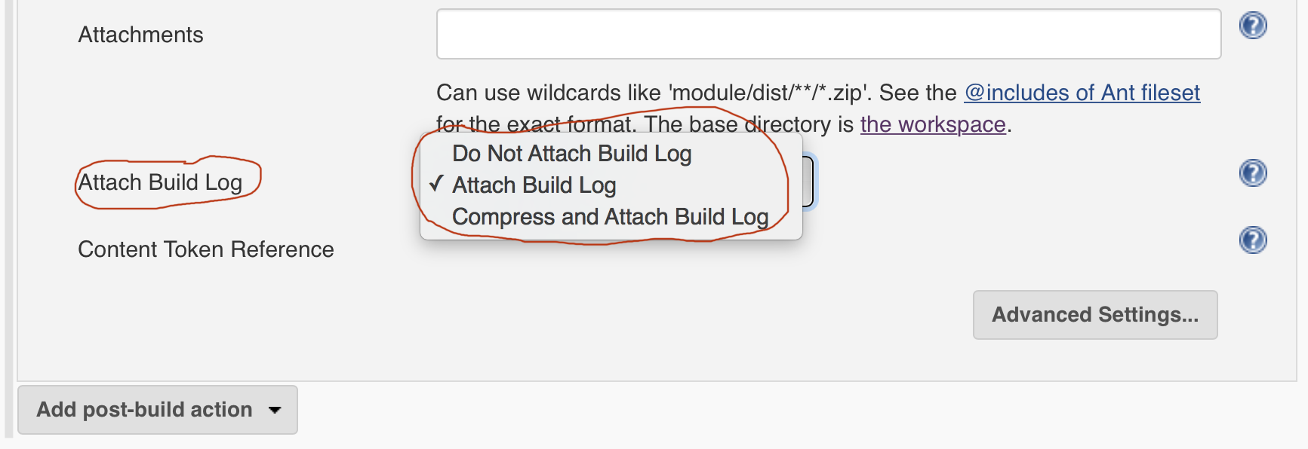](https://github.com/Salihz)

1. After done with attachment click on "Advanced Settings" button

[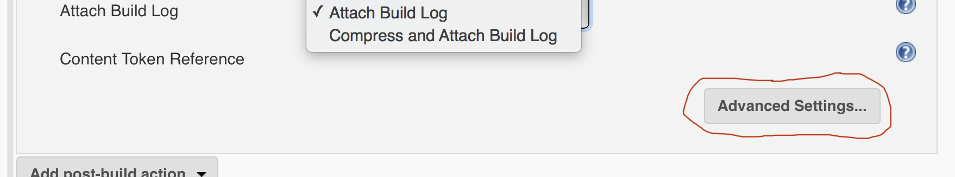](https://github.com/Salihz)

1. Click on "Add" and select "Recipient List" (because we set "Recipient List" in the step 4 above) and click on "Apply" and/or "Save" button(s)

[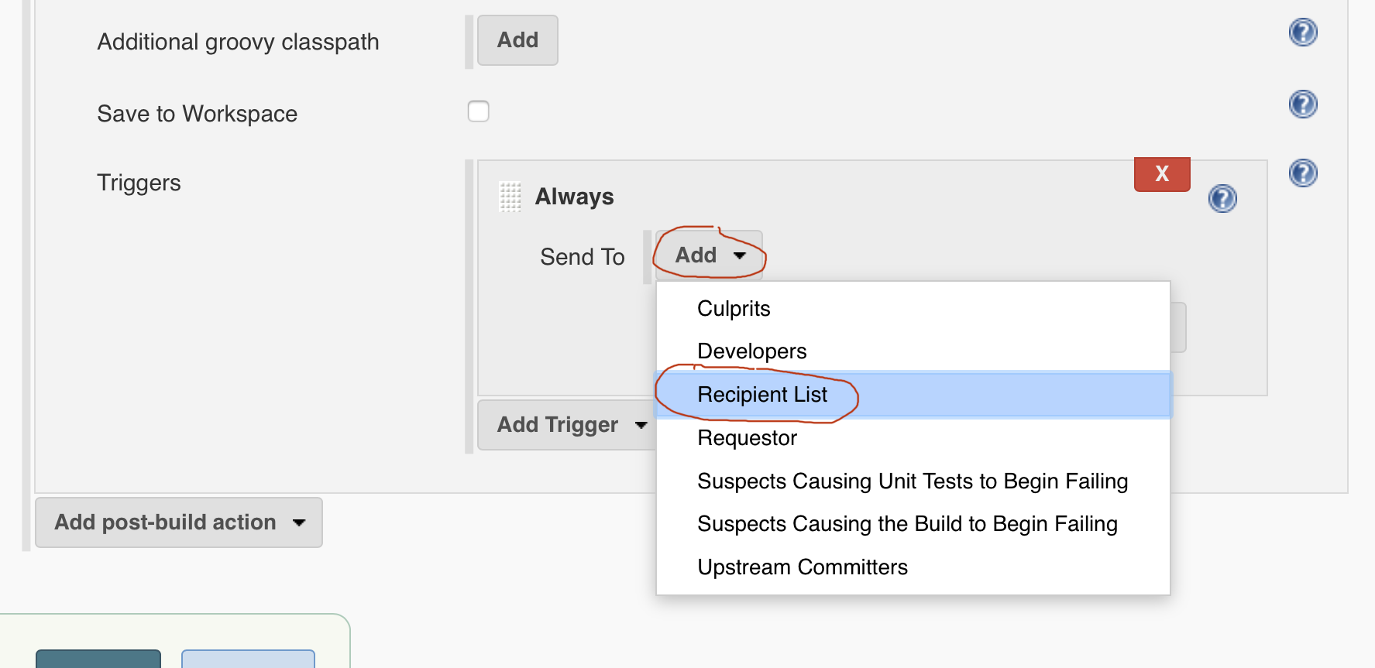](https://github.com/Salihz)

1. After first triggered or manually build you should receive an email report. Open the email.

[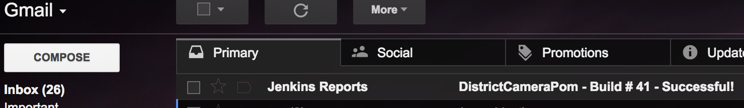](https://github.com/Salihz)

1. To view the console output results, click on the link (see console Output pic below)

To view the build log, click on the attachment or go to above mentioned link.

[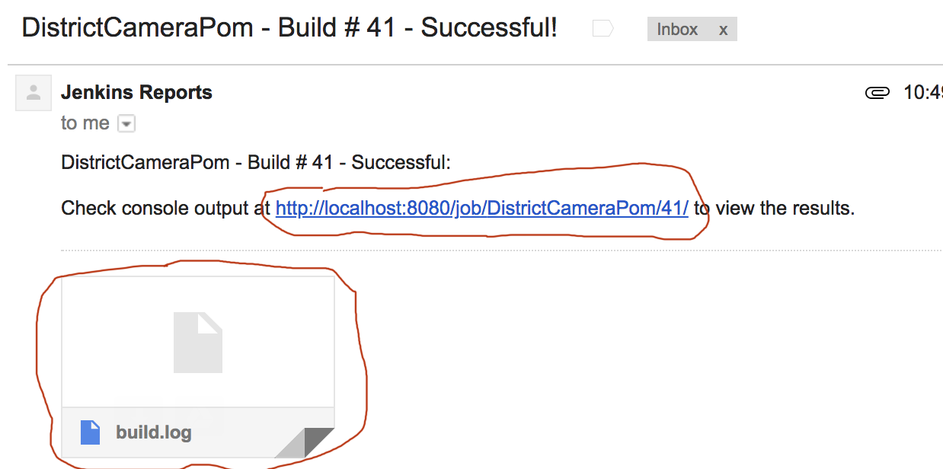](https://github.com/Salihz)

Click on console output then click on "View as plain text" to see build log

[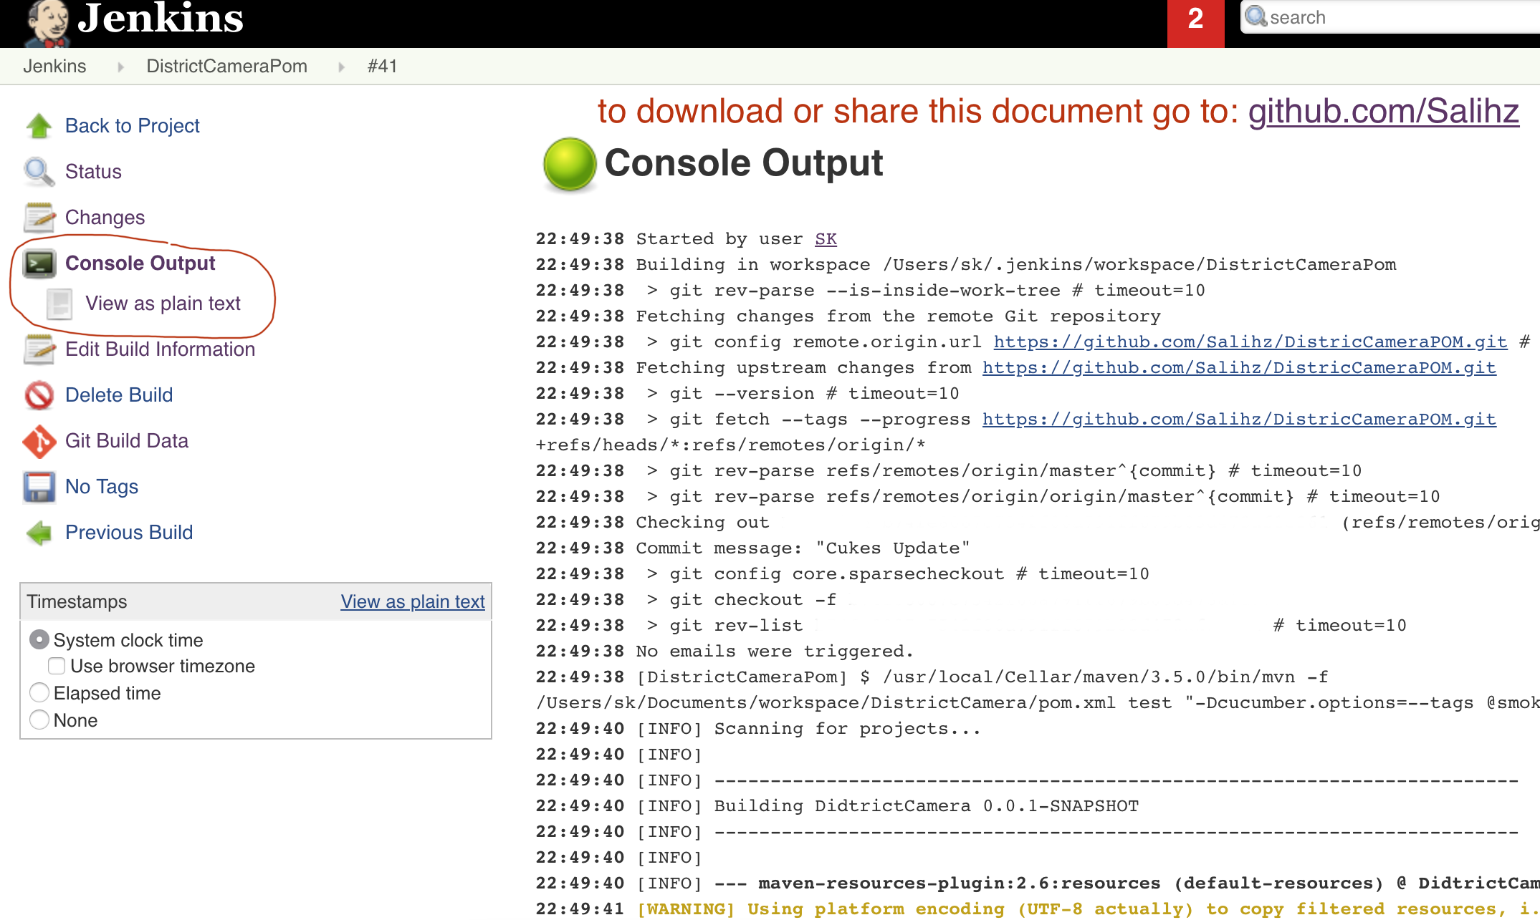](https://github.com/Salihz)

Links:

<https://jenkins.io>

<https://wiki.jenkins.io/display/JENKINS/Home>

<https://issues.jenkins-ci.org/secure/Dashboard.jspa>